PENETRATION TESTING REPORT
Penetration testing report for CTF called Empire: Breakout from VulnHub

9 JULY 2026
AUTHOR: SZYMON STEFAŃSKI
CLASSIFICATION: EDUCATIONAL
ENVIRONMENT: CONTROLLED ISOLATED LAB
VERSION: 1.0

Statement Of Confidentiality
The contents of this document have been developed by Szymon Stefański as a part of the educational path towards penetration tester carrier. This document presents the full process of capturing flags inside of a vulnerable machine called Empire: Breakout.
All contents of this document that will be used outside of its legal purposes and educational functions will be considered an illegal activity that the author does not take responsibility for.

Contents
Statement Of Confidentiality 2
Executive Summary 4
Approach 4
Scope 4
Assessment Overview and Recommendation 4
Penetration Test Assessment Summary 5
Summary of Findings 5
Compromised System Walkthrough 6
Detailed Walkthrough 6
Enumeration / information gathering 6
Exploitation 6
Post-Exploitation 6
Reproduction of the steps 7
Remediation Summary 11
Mitigation 11
References 11

Executive Summary
This document demonstrates the process of capturing the flag inside of a vulnerable machine called Empire: Breakout, which can be downloaded from VulnHub.

Approach
I performed testing under a „black box” approach on July 9 2026 without any credentials or advance knowledge about source code or the target. Testing was performed using a Kali Linux attack machine inside an isolated host-only network in VirtualBox. The goal was to find the flag inside of the machine through credentials stealing. Each weakness identified was documented and written down to further explain my way of thinking and approach.

Scope
The scope of this assessment was one internal network range and virtual machine access.
Host/URL/IP Address | Overview
192.168.239.5 | Empire Breakout machine IP address

Assessment Overview and Recommendation
During the internal penetration test against Empire: Breakout I managed to find several issues that I categorized and described by severity level.
One finding resolved around improper comments inside of source code for the main page. Anyone entering the page on http:192.168.239.5/ could view the source code and find poorly encoded credentials. It allowed me to find out the password and proceed further to find the username.
The next issue was sensitive information disclosure to an unauthenticated actor on SMB ( samba ), where unauthenticated user could enumerate over list of users by abusing RPC ( Remote Procedure Call ) like samr using SID enumeration.
Those two findings combined create Information Disclosure that lead to high risk impact of privilege escalation. This is a classic Broken authentication issue by OWASP Top 10 standard.

Penetration Test Assessment Summary
During testing I started as an unauthenticated user with no such information as configuration information, source code, files or users.

Summary of Findings
During the course of testing, I uncovered a total of 3 findings that posed a risk for the system of Empire: Breakout. The below table provides a summary of the findings by severity level.
Findings
High | Medium
2 | 1

Below is a high-level overview of each finding identified during testing. These findings are covered in depth in the Technical Findings Details section of this report.
# Findings | Severity Level | Finding Name
1 | High | Configuration ( Access to shell with Usermin for logged user )
2 | High | Inclusion of Sensitive Information in Source Code Comments
3 | Medium | Exposure of Sensitive Information to an Unauthorized Actor

Compromised System Walkthrough
During my testing of the assessment I was able to retrieve credentials for users and gain access to the shell inside of the Usermin session. This way I could get the flag and even create a reverse shell over tcp connecting using netcat. Steps below demonstrate processes of information gathering / enumeration, exploitation, privilege escalation and post-exploitation.

Detailed Walkthrough

Enumeration / information gathering
- Using the ping command I checked if 192.168.239.5 responded.
- I used nmap -A 192.168.239.5 for aggressive scanning, including OS detection, service version detection and TCP port scanning. This way I found that Empire Breakout runs apache server via http and on port 20000 has Miniserv webmin login page service active and on ports 139 and 445 smbd services.
- I used the gobuster tool to enumerate through directories and found /manual subpage.

Exploitation
- On the main page http://192.168.239.5 I looked into source code comments and found unprotected information for credentials encoded using brainfuck.
- Using the enum4linux tool I enumerated on smbclient to get the username for the login page.
- Using credentials I logged in to the Usermin interface and proceeded to the shell interface.
- Using an unrestricted shell interface I was able to find and read flag in the user.txt file.

Post-Exploitation
- I created a reverse shell over tcp using netcat tool as an additional step.
- During my search I came to the conclusion that any logged user can execute root level commands via interactive shell on Usermin.

Reproduction of the steps
Using nmap and gobuster I found information about the target and its active pages / services.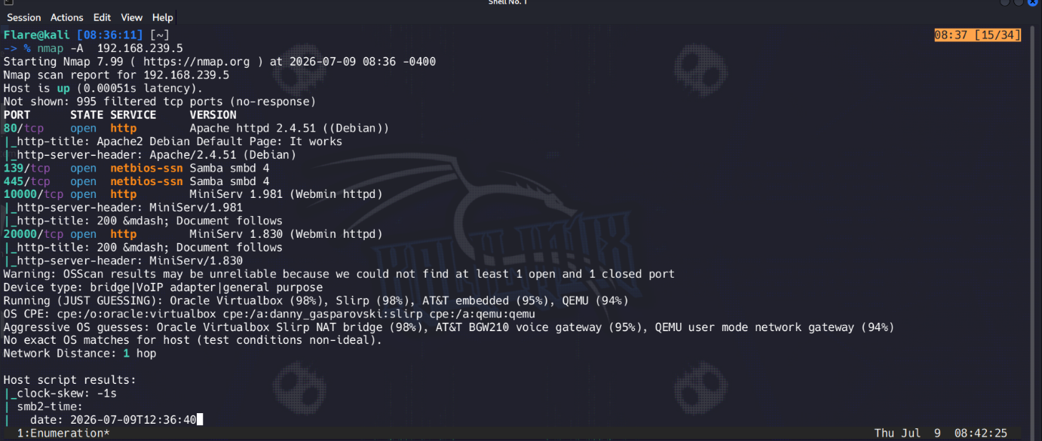
On the main page source I found comments, encoded with brainfuck, credentials ( password ). 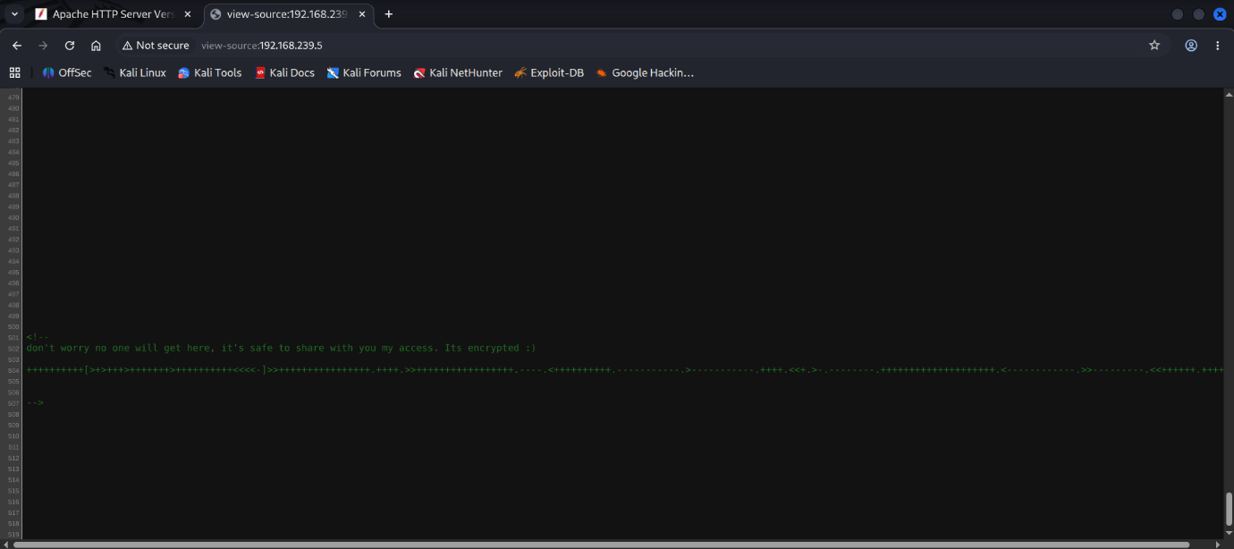
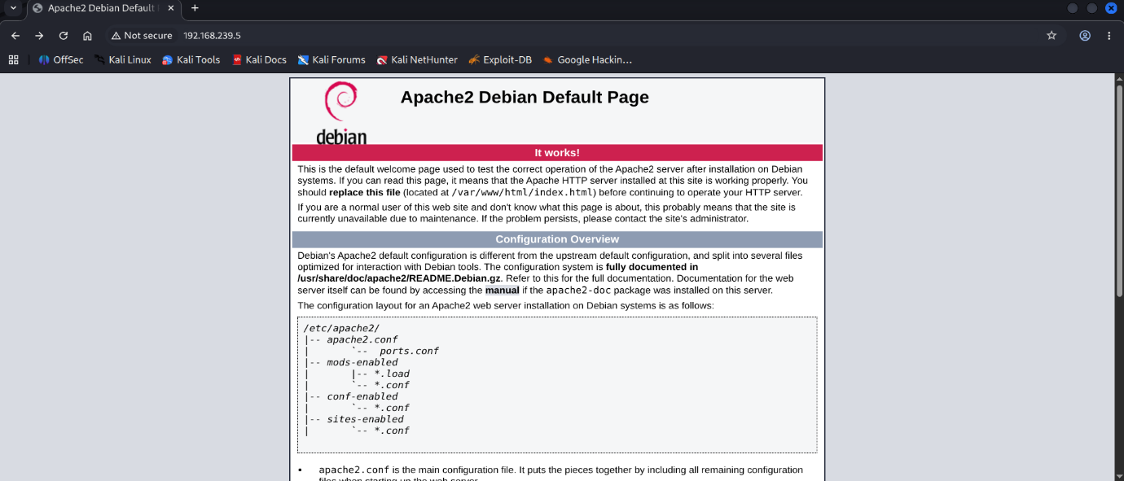
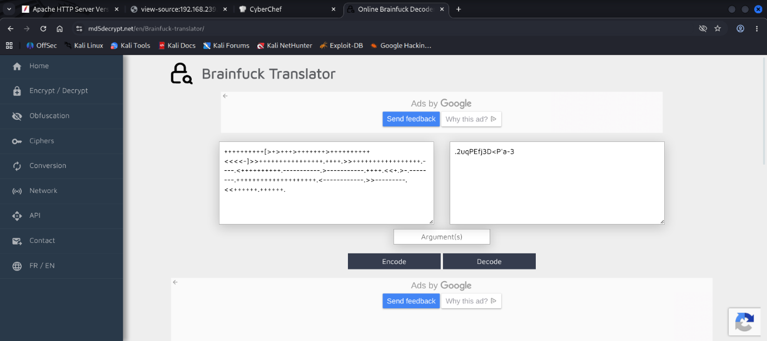
I used smbclient -L //192.168.239.5/ to check if anonymous login is active and proceed with enum4linux -a 192.168.239.5 to enumerate over user ids.
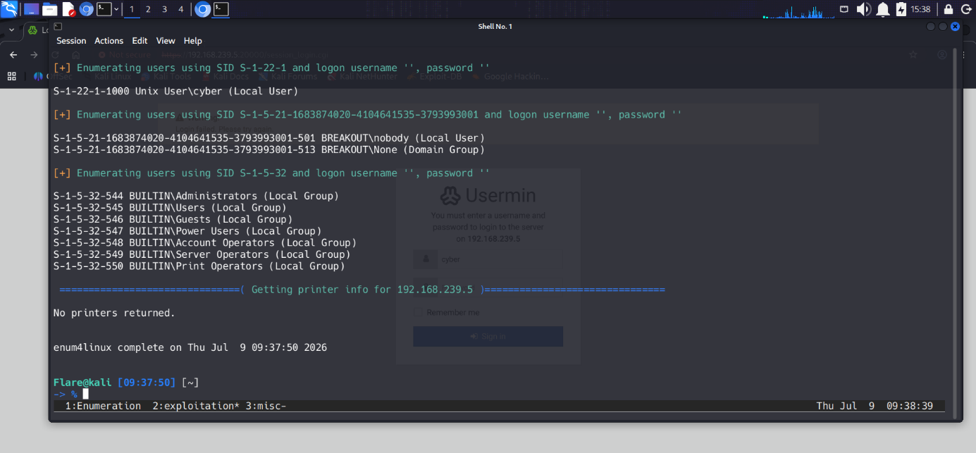
With credentials ready I went to 192.168.239.5:20000 login page and opened the Usermin interface.
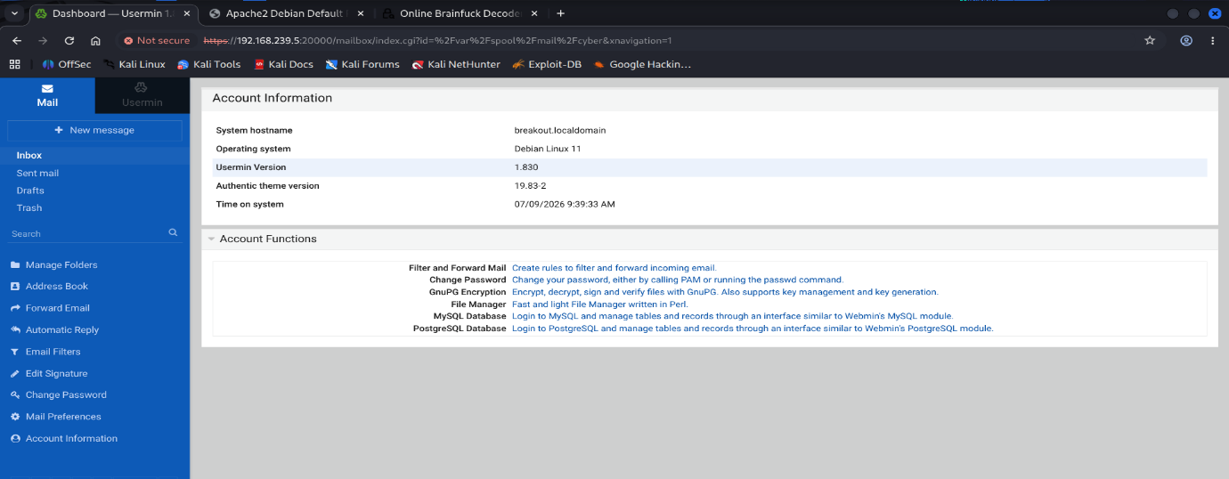
Using build-in shell terminal I found user.txt file and retrieved the flag.
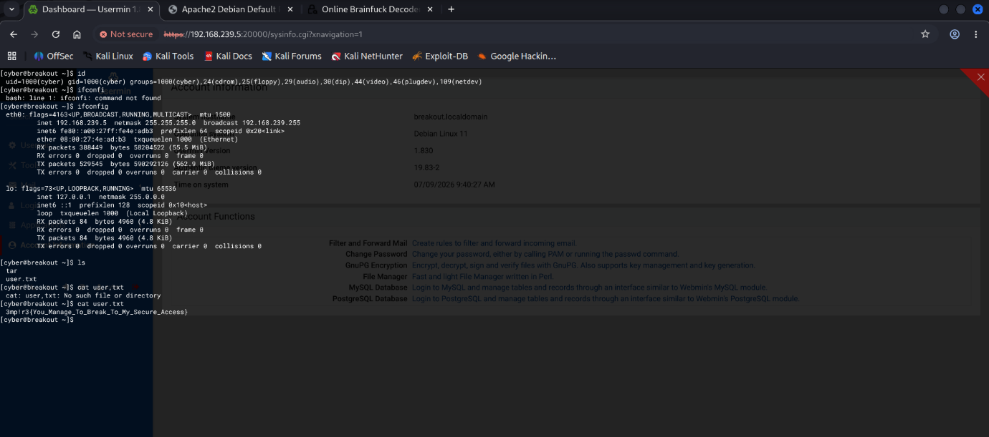
Bonus RCE ( Remote Code Execution ) presentation on compromised system.
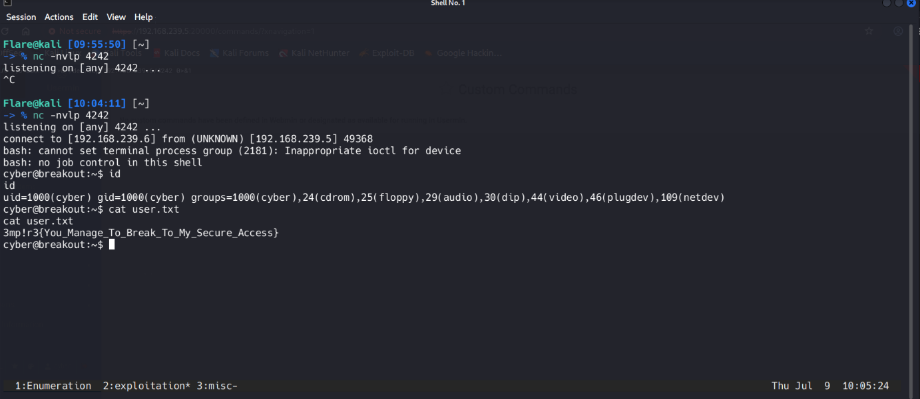

Remediation Summary
As a result of this assessment there are several vulnerabilities ( CWEs ) that are worth knowing in the real world. Abusing them led me from an unauthenticated user to a logged in user with full admin control.

Mitigation
- CWE-615 ( Inclusion of Sensitive Information in Source Code Comments ) :
  - Automatic scanner like TruffleHog to find hidden secrets in code and Strict Code Review.
- CWE-200 ( Exposure of Sensitive Information to an Unauthorized Actor ) :
  - Disabling SMBv1 and setting restrict anonymous = 2 inside of samba configuration files.
- CWE-16 ( Configuration ( Access to shell with Usermin for logged user ) :
  - Principle of least privilege for normal users

References
- https://cwe.mitre.org/data/definitions/200.html -> CWE-200 information page
- https://cwe.mitre.org/data/definitions/615.html -> CWE-615 information page
- https://cwe.mitre.org/data/definitions/16.html -> CWE-16 information page
- https://www.vulnhub.com -> Vulnhub website

